COS20019
Cloud Computing Architechture
Truong Ngoc Gia Hieu
105565520
Challenge Lab: Creating a Static Website for the Cafe
Scenario
Frank and Martha are a husband-and-wife team who own and operate a small café business that sells desserts and coffee. Their daughter, Sofía, and their other employee, Nikhil (who is a secondary school student), also work at the café. The café has a single location in a large city.

The café currently doesn’t have a marketing strategy. It gains new customers mostly when someone walks by, notices the café, and decides to try it. The café has a reputation for high-quality desserts and coffees, but the café's reputation is limited to people who have visited or who have heard about it from other café customers.

Sofía suggests to Frank and Martha that they should expand community awareness of what the café has to offer. The café doesn’t have a web presence yet, and it doesn’t currently use any cloud computing services. However, that situation is about to change.

A. Lab overview and objectives

In this lab, you use Amazon Simple Storage Service (Amazon S3) to build a static website and implement architectural best practices to protect and manage your data.

After completing this lab, you should be able to do the following:
- Host a static website by using Amazon S3.
- Implement one way to protect your data with Amazon S3.
- Implement a data lifecycle strategy in Amazon S3.
- Implement a disaster recovery (DR) strategy in Amazon S3.

At the end of this lab, your architecture should look like the following example:
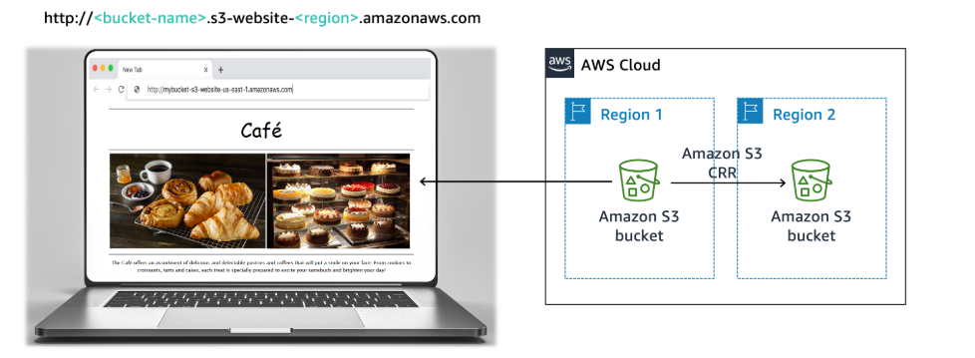

Note: In this challenge lab, you encounter a few tasks where step-by-step instructions are not provided. You must figure out how to complete the tasks on your own.

Duration
This lab requires approximately 60 minutes to complete.

AWS service restrictions
In this lab environment, access to AWS services and service actions might be restricted to the ones that are needed to complete the lab instructions. You might encounter errors if you attempt to access other services or perform actions beyond the ones that are described in this lab.

B. Accessing the AWS Management Console
To access the AWS Management Console, click button Start Lab and then wait until the circle next to the AWS turns from red to green.
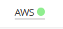

Figure 1: AWS Account Activated

C. A business request for the café: Launching a static website (challenge 1)
Sofía mentions to Nikhil that she would like the café to have a website that visually showcases the café's offerings. The website would also provide customers with business details, such as the location of the store, business hours, and telephone number.
Nikhil is happy that he has been asked to create the first website for the café.
For this first challenge, you take on the role of Nikhil and use Amazon S3 to create a basic website for the café.

Task 1: Extracting the files that you need for this lab
In this task, you extract the files that you need to create the static website.
- Download the .zip file that you need for this lab.
- Extract the files to your computer.
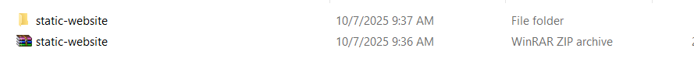
Notice that you have an index.html file and images folder that contain image files.
Figure 2: Zip file downloaded

Task 2: Creating an S3 bucket to host your static website
In this task, you create an S3 bucket and configure it to host your static website.
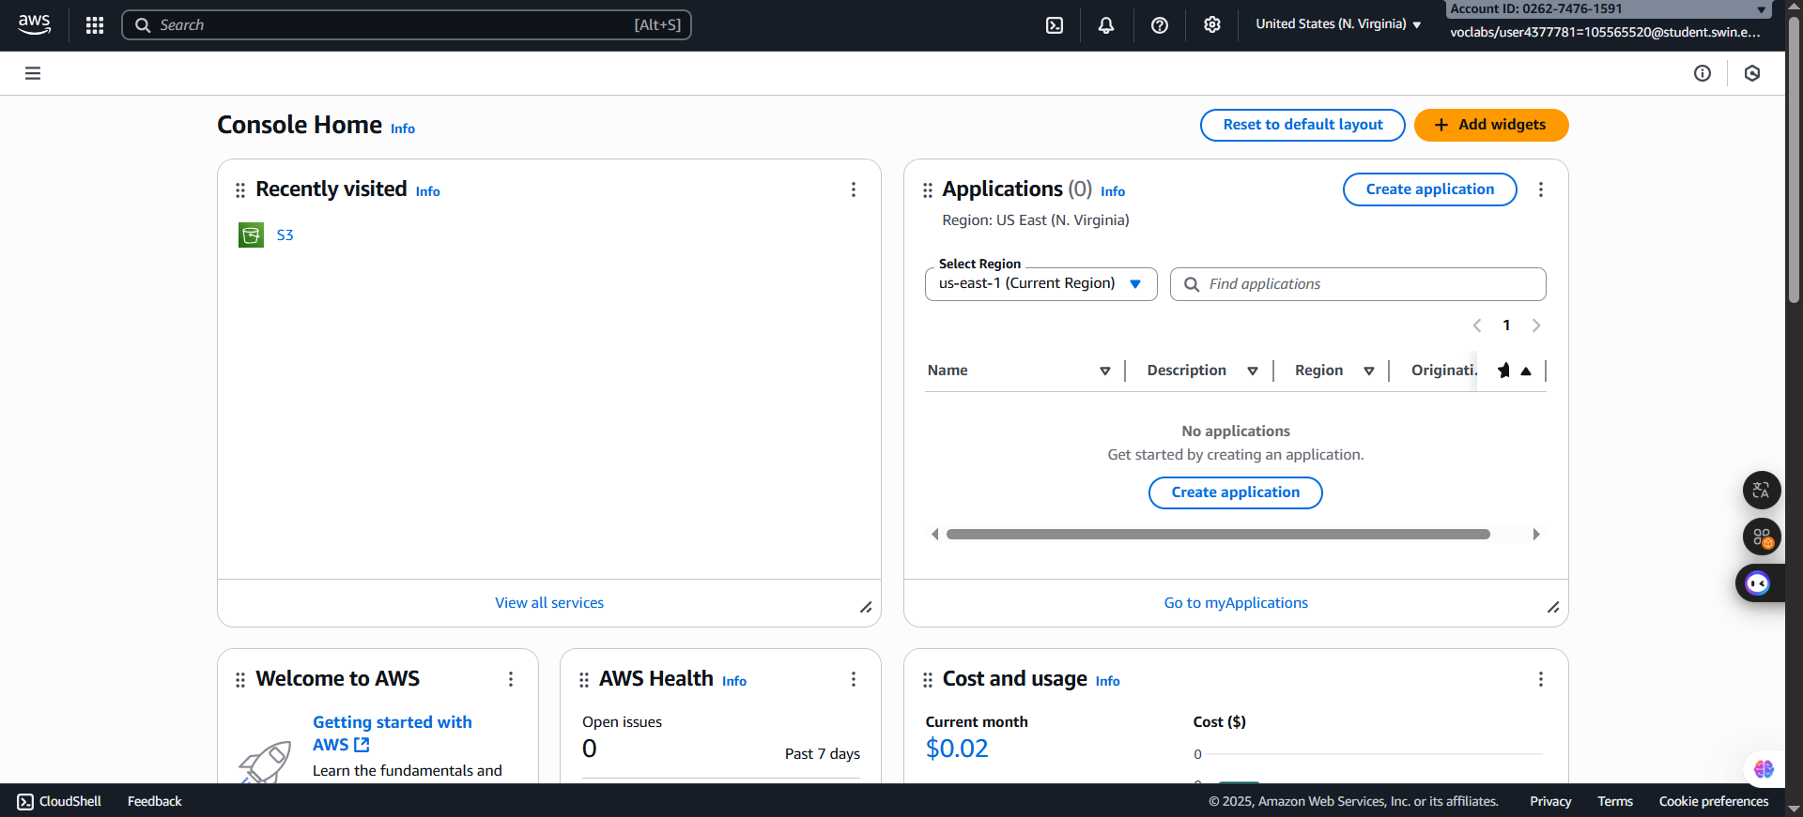
  - Open the Amazon S3 console.
Figure 3: AWS Management page

2.2 Create a bucket in the US East (N. Virginia) us-east-1 AWS Region to host your static website.
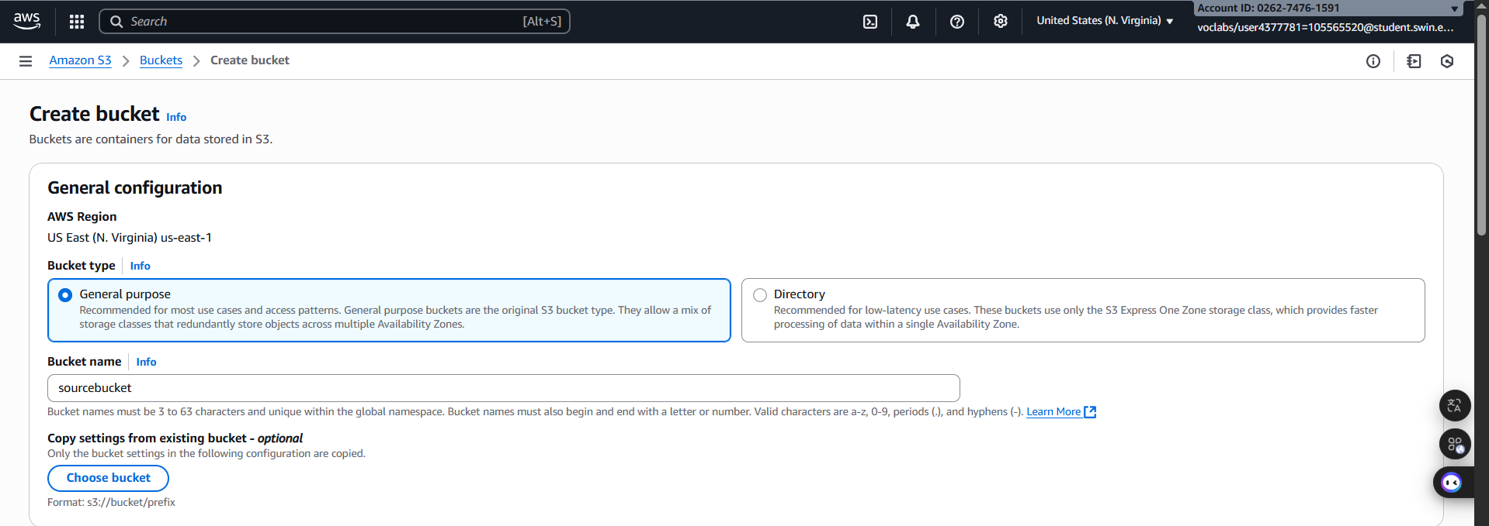
Tip: You must clear Block all public access and enable ACLs.
Figure 4: Bucket name configuration
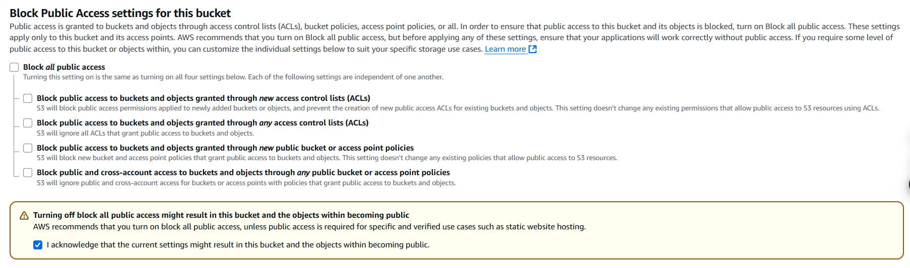
Figure 5: Block configuration

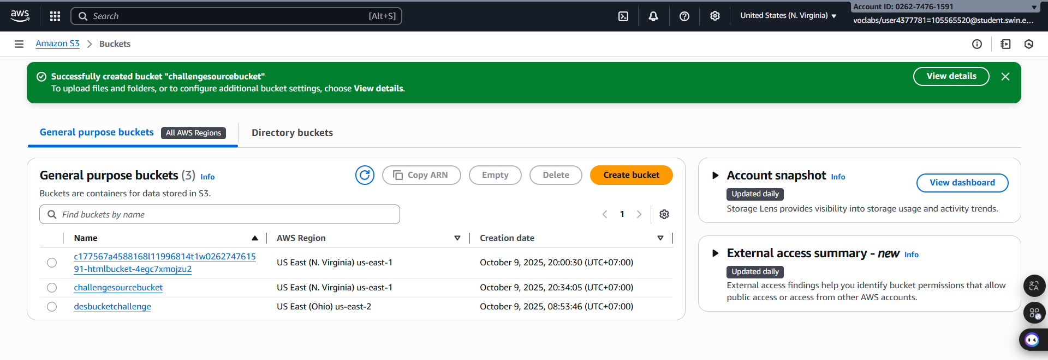
Figure 6: Bucket created successfully

2.3: Enable static website hosting on your bucket.
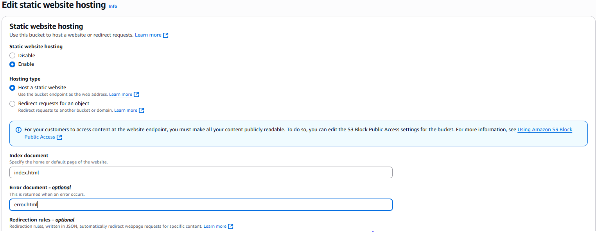
Tip: You use the index.html file for your index document.

Figure 7: Properties Configuration

Task 3: Uploading content to your S3 bucket
In this task, you upload the static files to your S3 bucket.
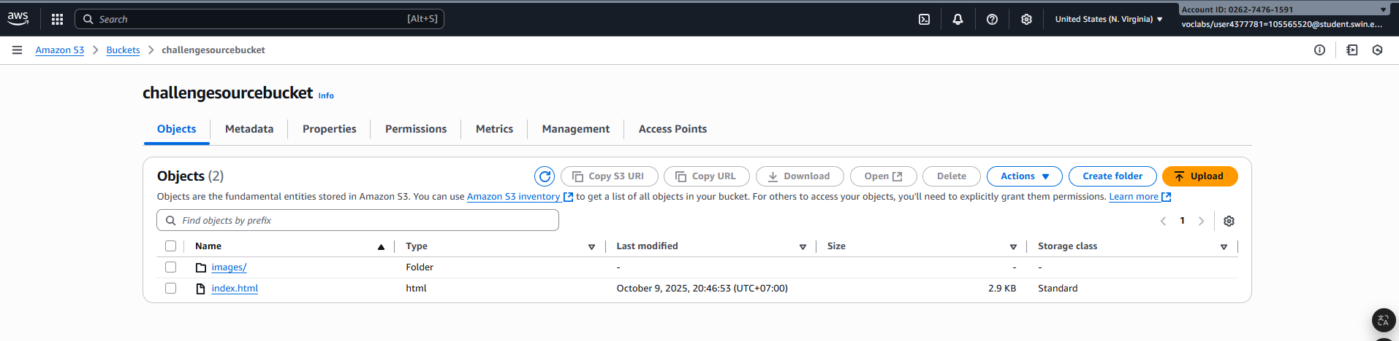
  - Upload the index.html file and the CSS and images folders to your S3 bucket.
Figure 8: Upload successful

  - In a separate web browser tab, open the endpoint link for your static website.

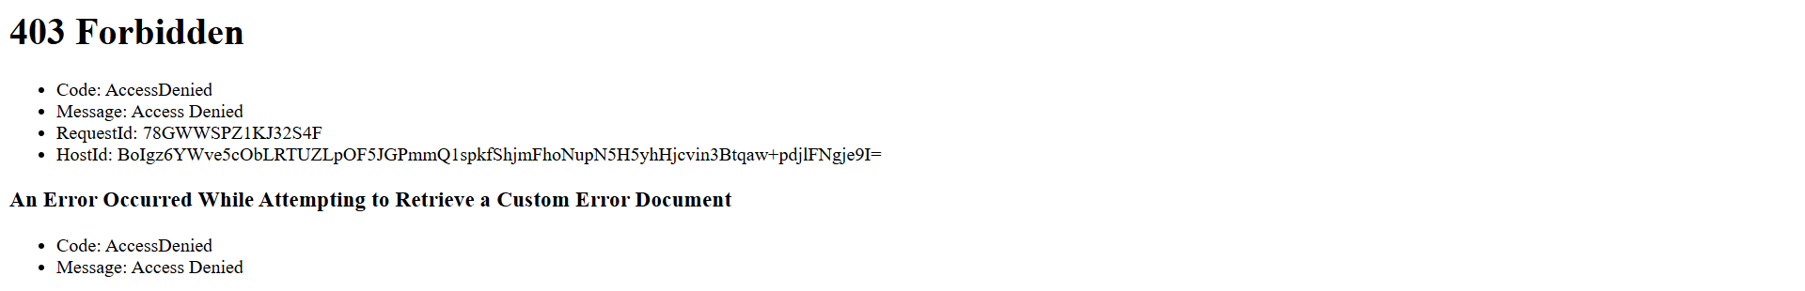
Figure 8: Launch static website
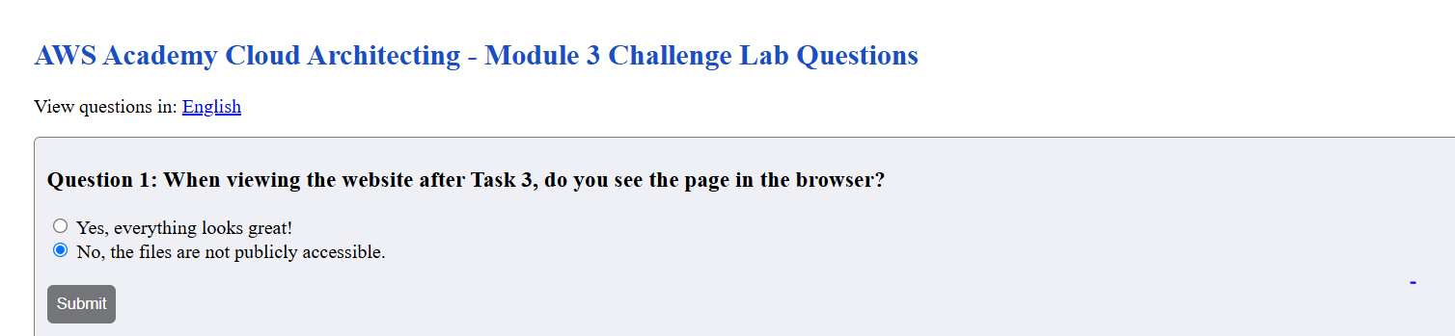
Figure 9: Question 1

Task 4: Creating a bucket policy to grant public read access
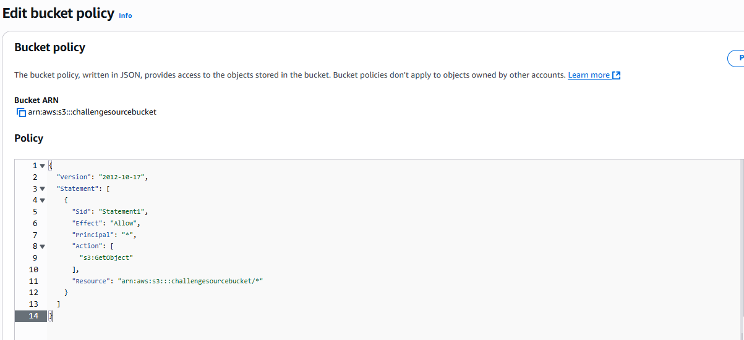
Figure 10: Bucket Policy Configuration

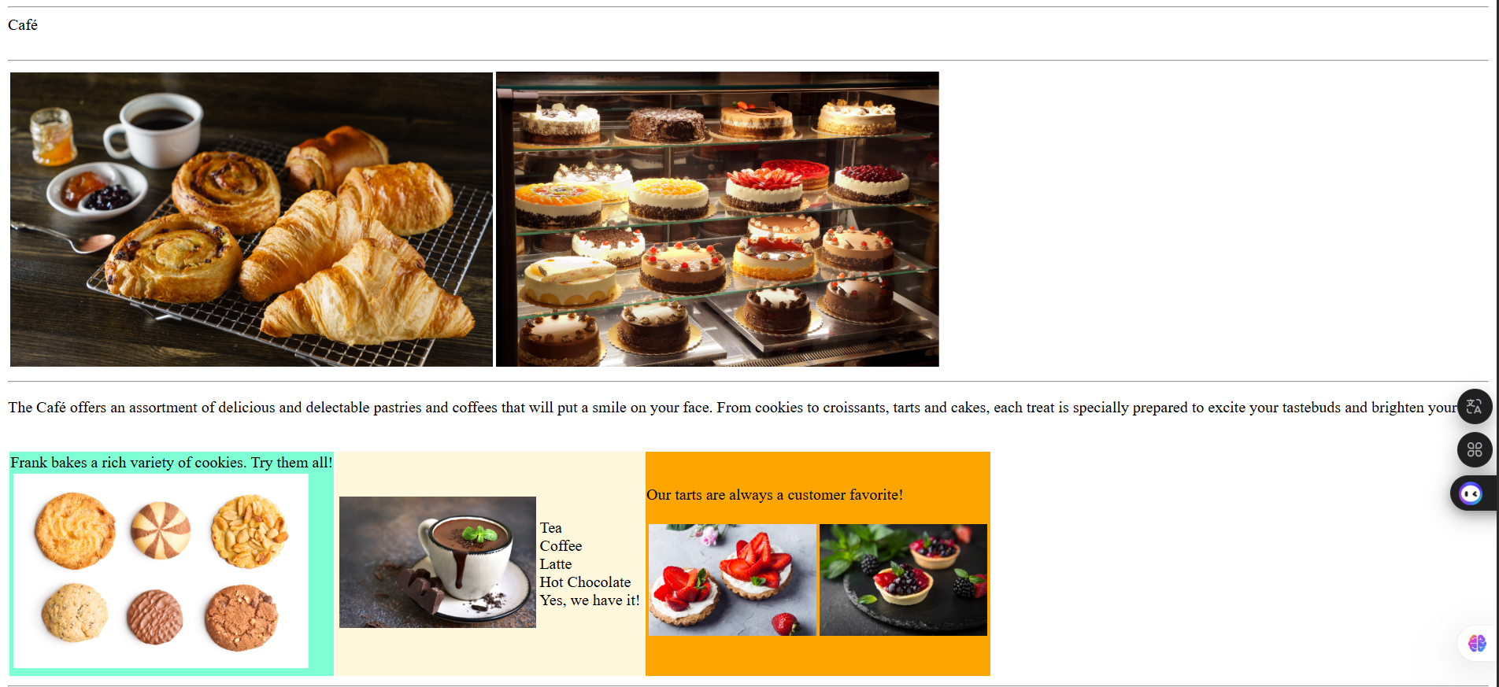
Figure 11: Website Launch Successfully

Task 5: Enabling versioning on the S3 bucket
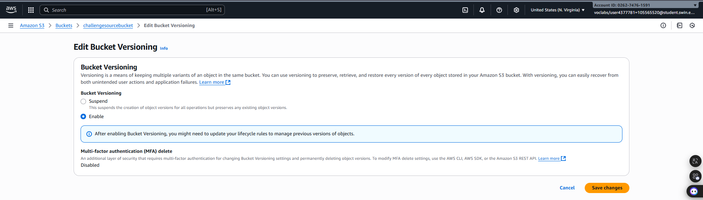
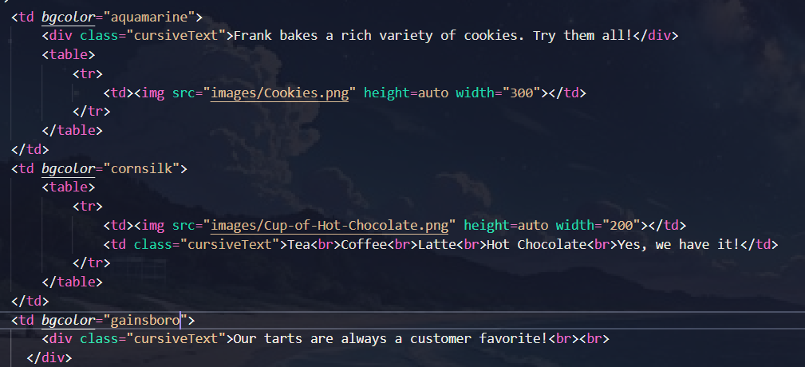
Figure 12: Bucket Version Configuration
Figure 13: Code Configuration
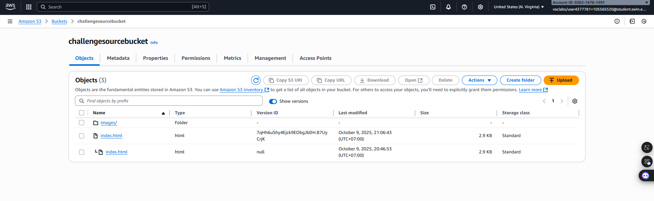
Figure 14: Upload Successful
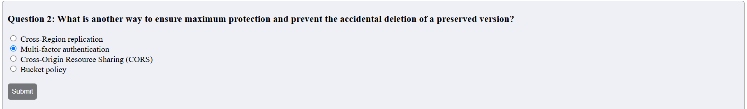
Figure 15: Question 2

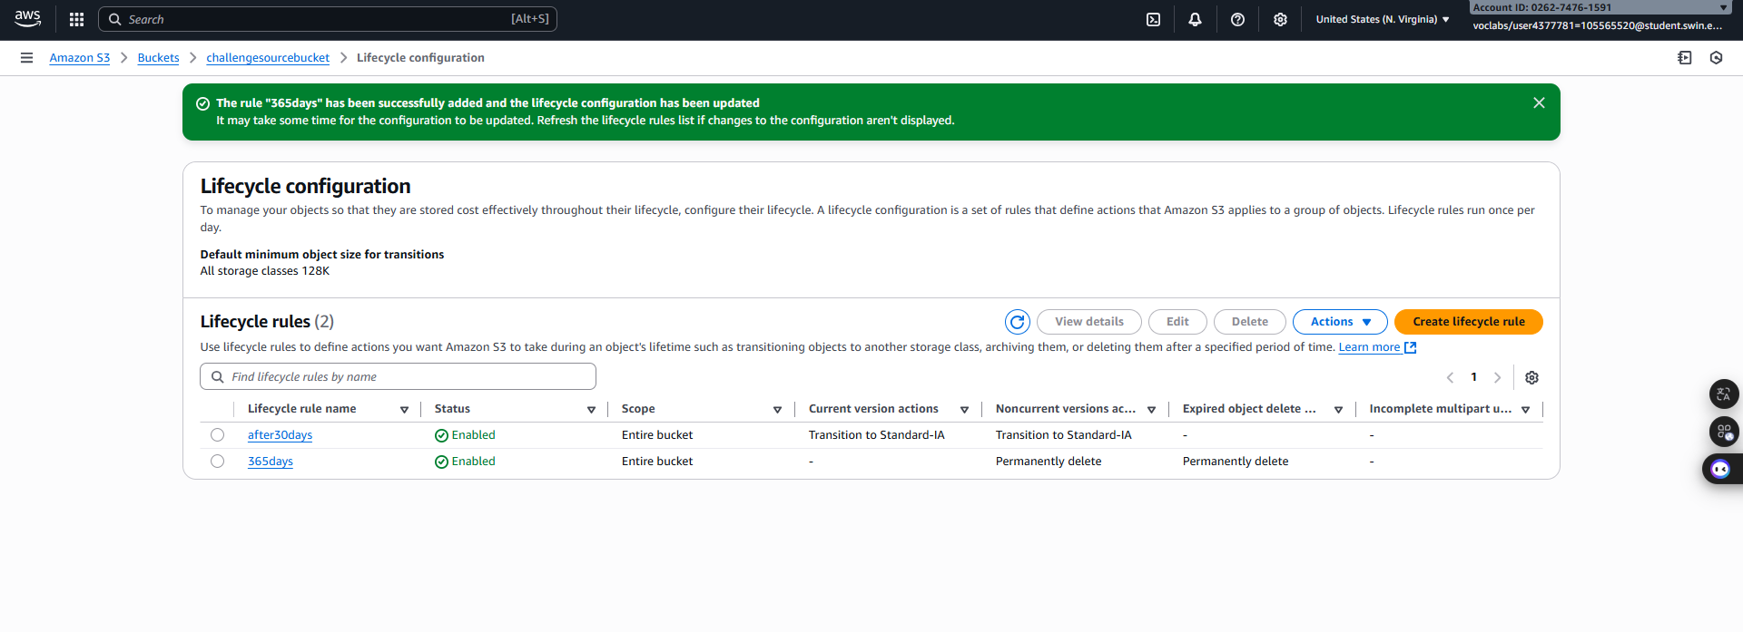
Task 6: Setting lifecycle policies

Figure 16: lifecycle policies

Task 7: Enabling cross-Region replication
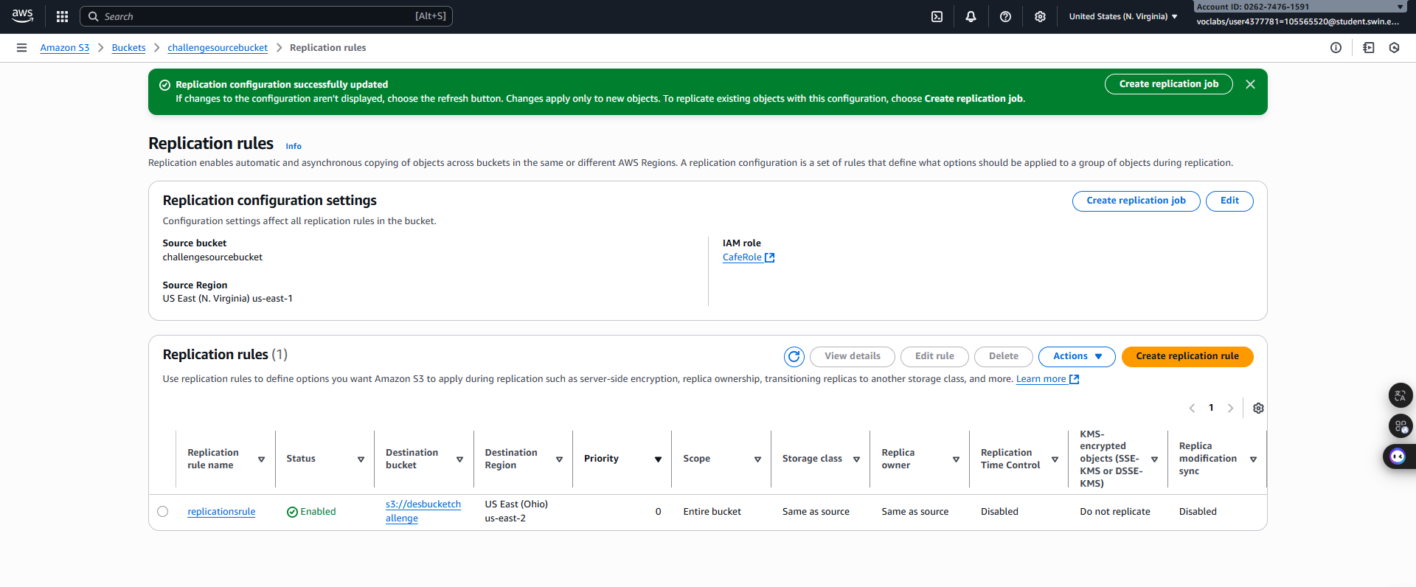
Figure 17: Replicate configure successful

